**EXP : 2 EMPLOYEE DATABASE**

**Aim:**

Consider the employee database given below:

**emp** (emp_id,emp_name, Street_No, city)

**works** (emp_id, company name, salary)

**company** (company name, city)

**manages** (emp_id, manager_id)

**Note: Emp_id should start with ‘E’ in Emp table and emp_id in works table must be the**

**emp_id from emp table .emp_id and manager_id in manages table must be the emp_id**

**from emp table**

**EMP TABLE**

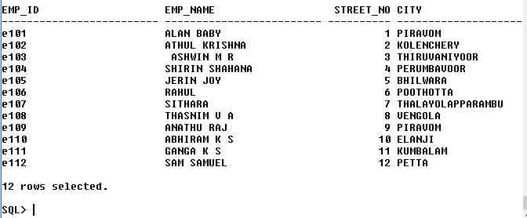

**COMPANY TABLE**

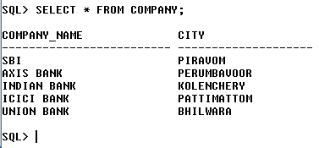

**WORKS TABLE**

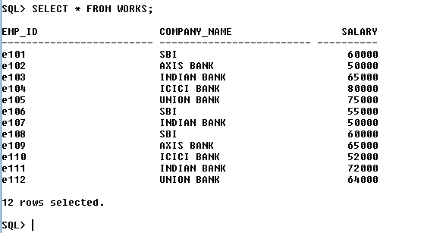

**MANAGES TABLE**

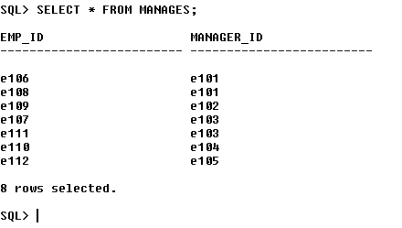

1. Find the names of all employees who work for SBI.

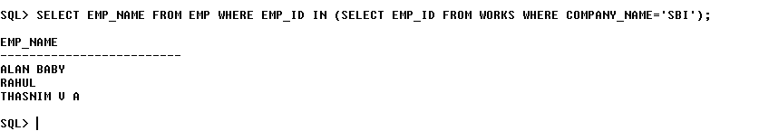

1. Find all employees in the database who live in the same cities as the companies for which they work.

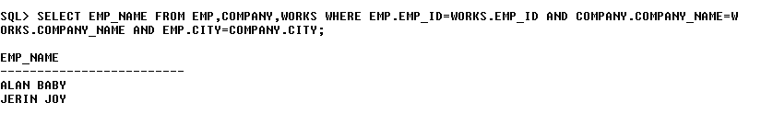

1. Find all employees who earn more than the average salary of all employees of their company.

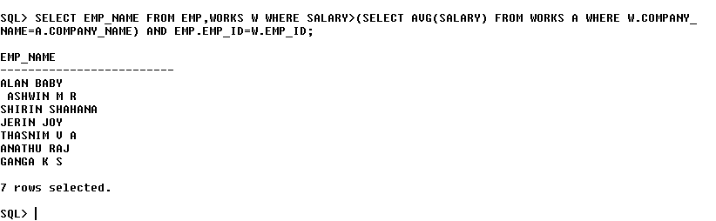

1. Give all managers of SBI a 10 percent raise.

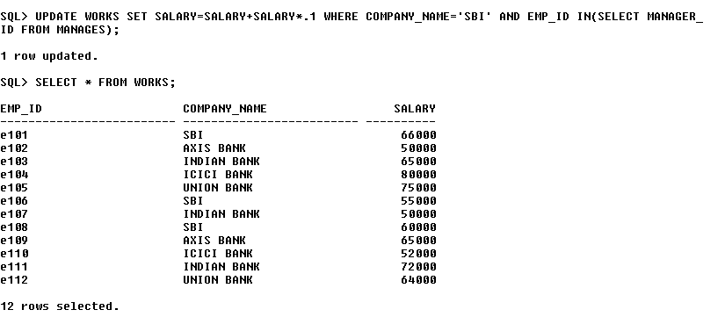

1. Find the company that has the most employees

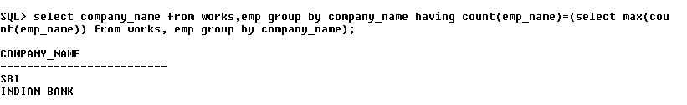

1. Find those companies whose employees earn a higher salary, on average than the average salary at Indian Bank.

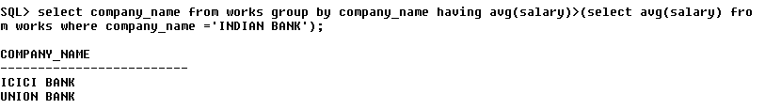

1. Query to find name and salary of all employees who earn more than each employee of ‘Indian Bank’

SQL> SELECT emp_name,salary from emp,works where emp.emp_id=works.emp_id and company_name !='INDIAN BANK' AND SALARY>(select min(salary) from works where company_name='INDIAN BANK');

